Creating Swatch Libraries (for Illustrator)

- Open the Swatches palette in Photoshop.
- Append a range of swatches to give you a good selection

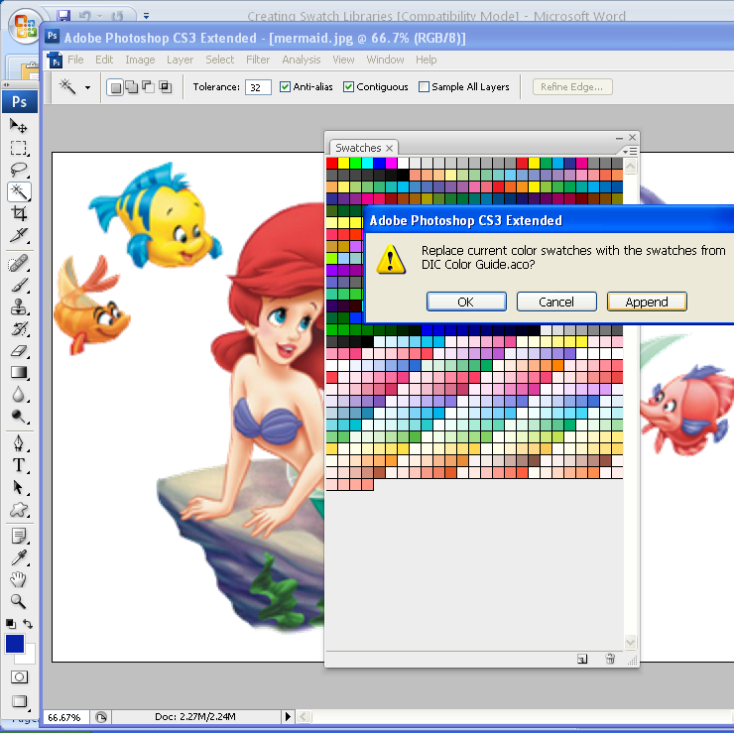
- Click on the flyaway menu at the top right, and choose "Save Swatches for Exchange" from the list of options.

- Select your folder and name the swatches
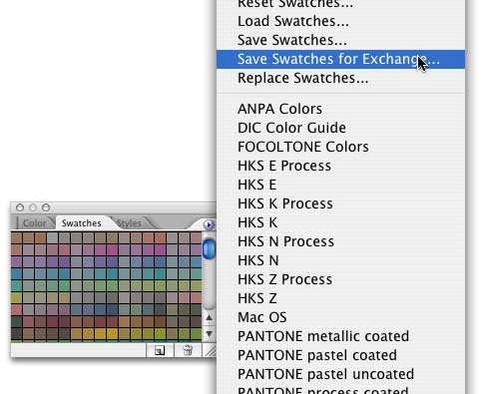

- This will allow you to create a swatch file with an ase extension, (do NOT use the usual aco extension if you want to use the swatches in Illustrator) Save this .ase file to your own folder.
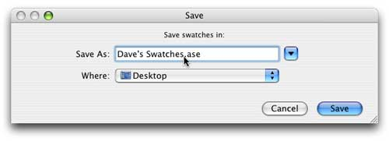
- Now, in Illustrator , open up the Swatches palette. Click the flyaway menu on the top right, and choose Open Swatch Library > [Your Library] from the list of options. This will open up the new swatch library in a separate palette.
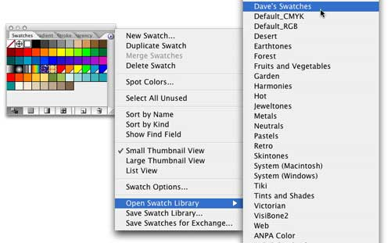
Okay, but what if you don't want to transfer your entire swatch library from Photoshop to Illustrator? What if you just want to transfer some of them to keep your swatches in Illustrator more manageable?
Here's how that works.
1. In Photoshop, go to Edit > Preset Manager. This opens up the Preset Manager dialog.
2. Select "Swatches" from the pull-down menu in the Preset Manager, and you will see all of the swatches that currently appear in your Swatches palette.
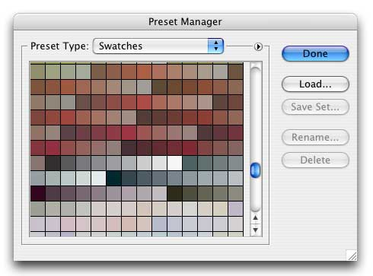
3. Now you can go in and pick and choose the swatches to export by holding down the Command key (Mac) or Control key (Windows) and clicking on the individual swatches you want.
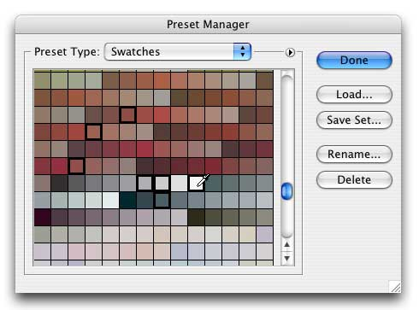
Or, if you have a contiguous block of swatches you want to export, click on the first one, then hold down the Shift key and click on the last one. This will select the first and last swatches, plus everything in between.
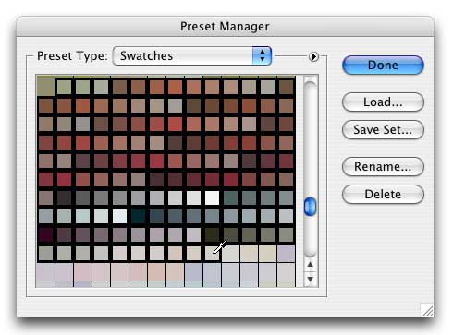
4. Now, click the little flyaway menu next to the pull-down menu. From there, choose the "Save Swatches for Exchange" option.
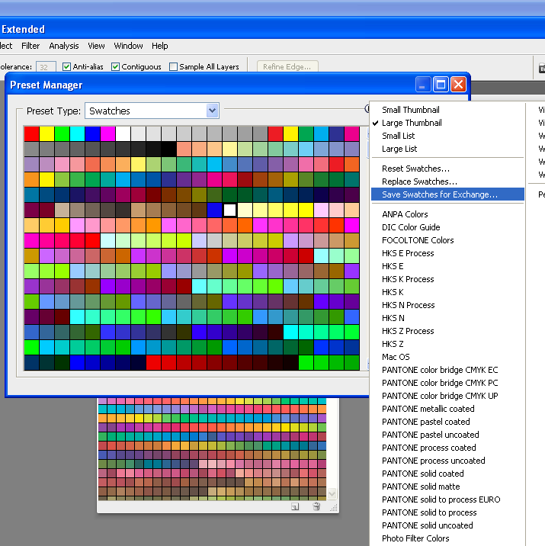

5. Again, save the swatch library to your Illustrator CS2/Presets/Swatches directory.
6. And, again, open the library in Illustrator using the flyaway menu in the Swatches palette. This will open up your newly created, smaller Photoshop swatch library in a new palette tab.
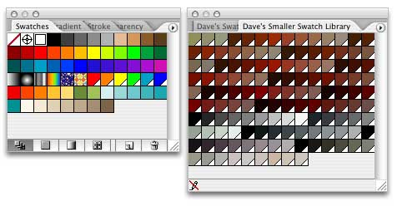
And that's it for that.

